Task 1
AIM:To calculate the sum of similarities of a string with all its suffixes.

ALGORITHM
- Read number of test cases t.
- For each string s:
- Initialize sum = length of s.
- Construct Z-array:
- For each index i, compute longest prefix match starting at i.
- Add all Z-values to sum.
- Print the sum .

PROGRAM

import java.util.*;
public class Solution {
public static void main(String[] args) {
Scanner sc = new Scanner(System.in);
int t = sc.nextInt();
sc.nextLine();
while (t-- > 0) {
String s = sc.nextLine();
System.out.println(stringSimilarity(s));
}sc.close();
}private static long stringSimilarity(String s) {
int n = s.length();
int[] z = new int[n];

int left = 0, right = 0;

for (int i = 1; i < n; i++) {
if (i <= right) {
z[i] = Math.min(right - i + 1, z[i - left]);
}

while (i + z[i] < n && s.charAt(z[i]) == s.charAt(i + z[i])) {
z[i]++;
}

if (i + z[i] - 1 > right) {
left = i;
right = i + z[i] - 1;
}
}

long sum = n;

for (int i = 0; i < n; i++) {
sum += z[i];
}

return sum;
}
}

OUTPUT

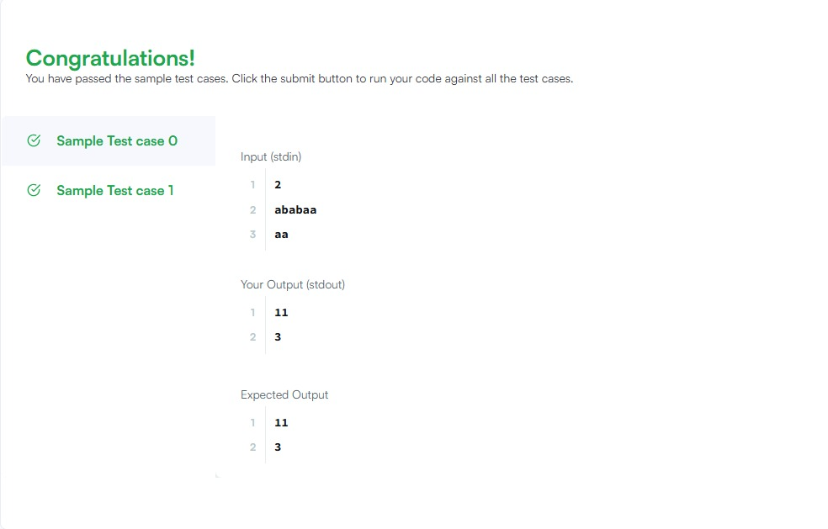

RESULT:Thus is an java program for The total similarity value for each string is printed has been executed successfully .

Task 2
AIM:To check whether a string can be formed by repeating a substring.

ALGORITHM

- Read string s.
- Create a new string temp = s + s.
- Remove first and last character of temp.
- Check if s exists inside temp.
- If yes → return true, else false.

PROGRAM

class Solution {
public boolean repeatedSubstringPattern(String s) {
String doubled = s + s;
String trimmed = doubled.substring(1, doubled.length() - 1);
return trimmed.contains(s);
}
}

OUTPUT

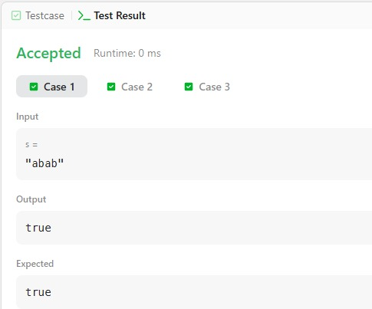

RESULT: Thus is an java program to Print true if the string is a repeated pattern, otherwise false has been executed successfully .

Task 3
AIM:To determine whether two strings share a common substring.

ALGORITHM

- Read number of test cases.
- For each pair s1, s2
- Store characters of s1 in a boolean array. Traverse s2:
- If any character exists in array → print "YES".
• Else print "NO".

PROGRAM

import java.util.*;

public class Solution {
public static String twoStrings(String s1, String s2) {
boolean[] seen = new boolean[26];

for (char c : s1.toCharArray())
seen[c - 'a'] = true;

for (char c : s2.toCharArray())
if (seen[c - 'a']) return "YES";

return "NO";
}
}
OUTPUT

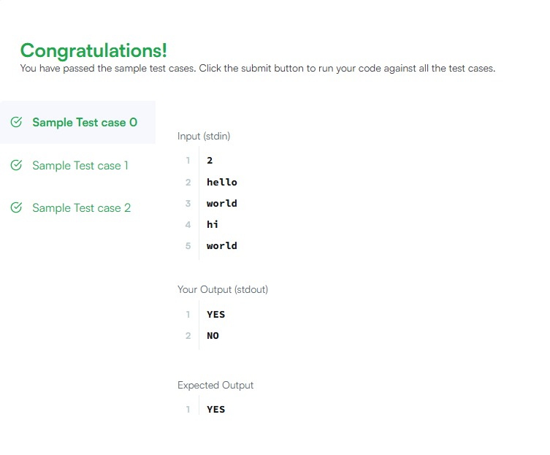

RESULT:Thus is an java program to Outputs "YES" if a common substring exists, otherwise "NO" has been executed successfully

Task 4

AIM:To check if one string is a rotation of another.

ALGORITHM:

1.Read strings s and goal.
2.If lengths differ → return false.
3.Create temp = s + s.
4.Check if goal is a substring of temp.
5.Return result.

PROGRAM
class Solution {
public boolean rotateString(String s, String goal) {
if (s.length() != goal.length()) {
return false;
}

String doubled = s + s;
return doubled.contains(goal);
}
}

OUTPUT:
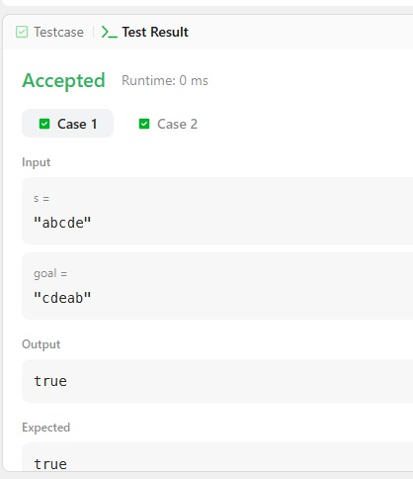

RESULT:Thus is an java program for Print true if rotation is possible, otherwise false has been executed successfully.

Task 5

AIM: To count altered characters in SOS signal.

ALGORITHM:

- Read string s.
- Initialize count = 0.
- Traverse string:
- If index % 3 == 0 or 2 → expected 'S'
- If index % 3 == 1 → expected 'O'
- Compare and increment count if mismatch.
- Print count.

PROGRAM

import java.util.*;

public class Solution {
public static int marsExploration(String s) {
int count = 0;

for (int i = 0; i < s.length(); i++) {
if ((i % 3 == 0 || i % 3 == 2) && s.charAt(i) != 'S')
count++;
else if (i % 3 == 1 && s.charAt(i) != 'O')
count++;
}

return count;
}
}

OUTPUT
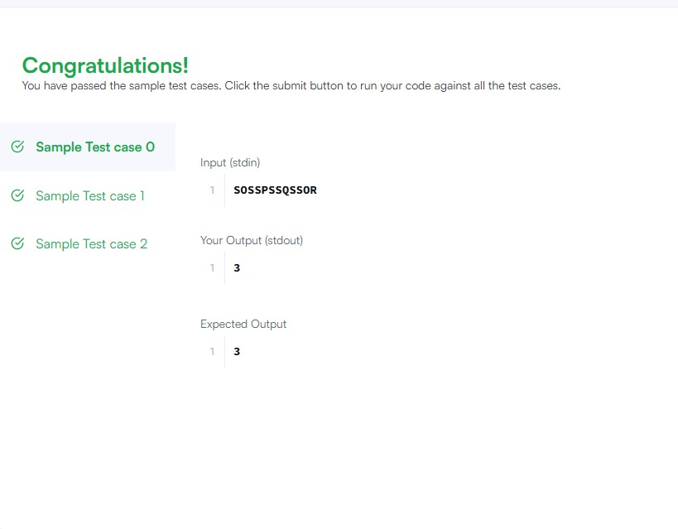

RESULT: Thus is an java program to Displays number of altered characters has been executed successfully

Task 6

AIM: To move all zeros in an integer array to the end while maintaining the relative order of non-zero elements in-place.

ALGORITHM:

- Use a pointer lastNonZeroFoundAt to keep track of where the next non-zero element should be placed.
- Iterate through the array; whenever a non-zero element is encountered, swap it with the element at lastNonZeroFoundAt.
- Increment the pointer after each swap to progress through the array.

PROGRAM

import java.util.Arrays;

public class Main {
public static void moveZeroes(int[] nums) {
int lastNonZeroFoundAt = 0;
for (int i = 0; i < nums.length; i++) {
if (nums[i] != 0) {
int temp = nums[lastNonZeroFoundAt];
nums[lastNonZeroFoundAt] = nums[i];
nums[i] = temp;
lastNonZeroFoundAt++;
}
}
}

public static void main(String[] args) {
int[] input = {0, 1, 0, 3, 12};
moveZeroes(input);
System.out.println("Output: " + Arrays.toString(input));
}
}
OUTPUT

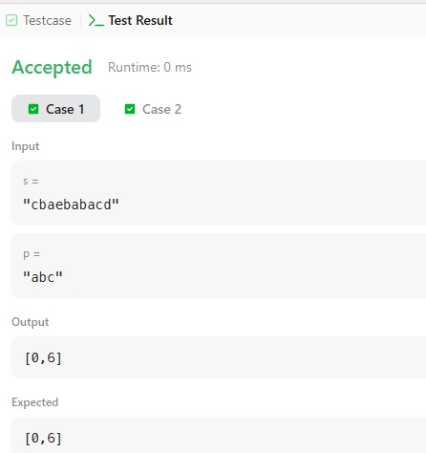

RESULT: Thus, the program has been executed successfully and output has been verified.

Task 7

AIM: To calculate the absolute difference between the sums of the primary and secondary diagonals of a square matrix.

ALGORITHM:

- Initialize two sum variables, p (primary) and s (secondary).
- Traverse the matrix with a single loop from to .
- Accumulate the value at matrix[i][i] for the primary diagonal and matrix[i][n-1-i] for the secondary diagonal.
- Return the absolute difference using Math.abs().

PROGRAM

public class Solution {
public static int diagonalDifference(int[][] arr) {
int p = 0, s = 0, n = arr.length;
for (int i = 0; i < n; i++) {
p += arr[i][i];
s += arr[i][n - 1 - i];
}
return Math.abs(p - s);
}

public static void main(String[] args) {
int[][] matrix = {{11, 2, 4}, {4, 5, 6}, {10, 8, -12}};
System.out.println("Result: " + diagonalDifference(matrix));
}
}

OUTPUT

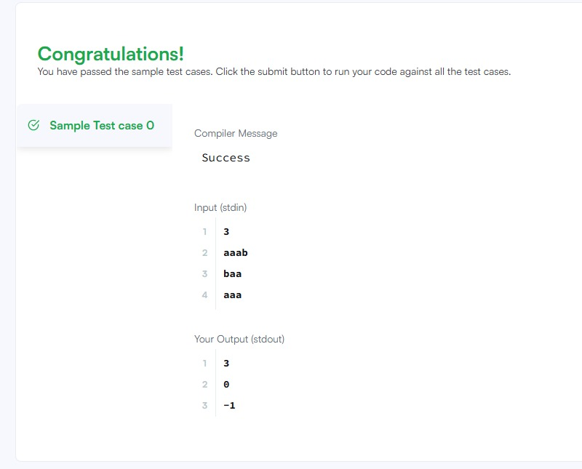

RESULT: Thus, the program has been executed successfully and output has been verified.

Task 8

AIM: To flip a matrix over its main diagonal, switching the row and column indices.

ALGORITHM:

- Get the original dimensions (rows) and (columns).
- Initialize a new empty matrix of size .
- Use nested loops to map newMatrix[c][r] = oldMatrix[r][c].

PROGRAM

import java.util.Arrays;

public class Solution {
public static int[][] transpose(int[][] matrix) {
int R = matrix.length, C = matrix[0].length;
int[][] ans = new int[C][R];
for (int r = 0; r < R; r++) {
for (int c = 0; c < C; c++) {
ans[c][r] = matrix[r][c];
}
}
return ans;
}
public static void main(String[] args) {
int[][] mat = {{1, 2, 3}, {4, 5, 6}};
int[][] result = transpose(mat);
System.out.println("Transposed: " + Arrays.deepToString(result));
}
}
OUTPUT

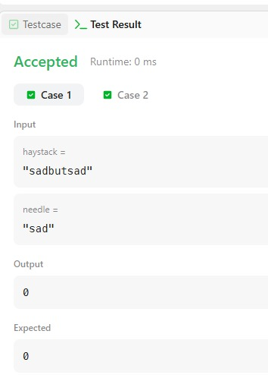

RESULT: Thus, the program has been executed successfully and output has been verified.

Task 9

AIM: To create a matrix where each cell contains the sum of all original elements within a distance .

ALGORITHM:

- Use a 2D Prefix Sum array where sum[i+1][j+1] stores the total sum from to .
- For each cell, calculate the bounding indices and using .
- Use the formula Sum = sum[r2+1][c2+1] - sum[r1][c2+1] - sum[r2+1][c1] + sum[r1][c1] to find the block sum in .

PROGRAM

import java.util.Arrays;

public class Solution {
public static int[][] matrixBlockSum(int[][] mat, int k) {
int m = mat.length, n = mat[0].length;
int[][] sum = new int[m + 1][n + 1];
for (int i = 0; i < m; i++)
for (int j = 0; j < n; j++)
sum[i+1][j+1] = mat[i][j] + sum[i][j+1] + sum[i+1][j] - sum[i][j];

int[][] ans = new int[m][n];
for (int i = 0; i < m; i++) {
for (int j = 0; j < n; j++) {
int r1 = Math.max(0, i - k), c1 = Math.max(0, j - k);
int r2 = Math.min(m - 1, i + k), c2 = Math.min(n - 1, j + k);
ans[i][j] = sum[r2+1][c2+1] - sum[r1][c2+1] - sum[r2+1][c1] + sum[r1][c1];
}
}
return ans;
}

public static void main(String[] args) {
int[][] mat = {{1, 2, 3}, {4, 5, 6}, {7, 8, 9}};
int[][] res = matrixBlockSum(mat, 1);
System.out.println("Block Sum (K=1): " + Arrays.deepToString(res));
}
}

OUTPUT :

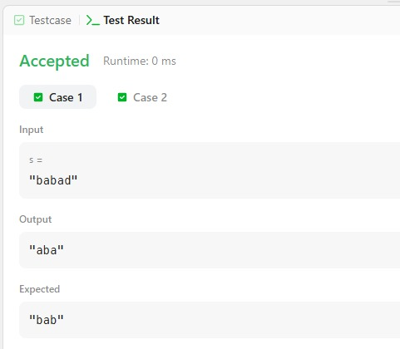

RESULT: Thus, the program has been executed successfully and output has been verified.

Task 10

AIM: To rotate each layer of an matrix counter-clockwise by steps.

ALGORITHM:

- Determine the number of concentric layers as .
- For each layer, extract elements into a 1D list (top, right, bottom, left).
- Rotate the list by .
- Place elements from the rotated list back into the original matrix positions.

PROGRAM

import java.util.*;

public class Task10 {
public static void matrixRotation(int[][] matrix, int r) {
int m = matrix.length, n = matrix[0].length;
int layers = Math.min(m, n) / 2;
for (int l = 0; l < layers; l++) {
List<Integer> list = new ArrayList<>();
for (int j = l; j < n - l; j++) list.add(matrix[l][j]);
for (int i = l + 1; i < m - l; i++) list.add(matrix[i][n - 1 - l]);
for (int j = n - 2 - l; j >= l; j--) list.add(matrix[m - 1 - l][j]);
for (int i = m - 2 - l; i > l; i--) list.add(matrix[i][l]);

int size = list.size();
int shift = r % size;
int idx = 0;
for (int j = l; j < n - l; j++) matrix[l][j] = list.get((idx++ + shift) % size);
for (int i = l + 1; i < m - l; i++) matrix[i][n - 1 - l] = list.get((idx++ + shift) % size);
for (int j = n - 2 - l; j >= l; j--) matrix[m - 1 - l][j] = list.get((idx++ + shift) % size);
for (int i = m - 2 - l; i > l; i--) matrix[i][l] = list.get((idx++ + shift) % size);
}
}

public static void main(String[] args) {
int[][] mat = {{1, 2, 3, 4}, {5, 6, 7, 8}, {9, 10, 11, 12}, {13, 14, 15, 16}};
matrixRotation(mat, 1);
for (int[] row : mat) System.out.println(Arrays.toString(row));
}
}

OUTPUT :

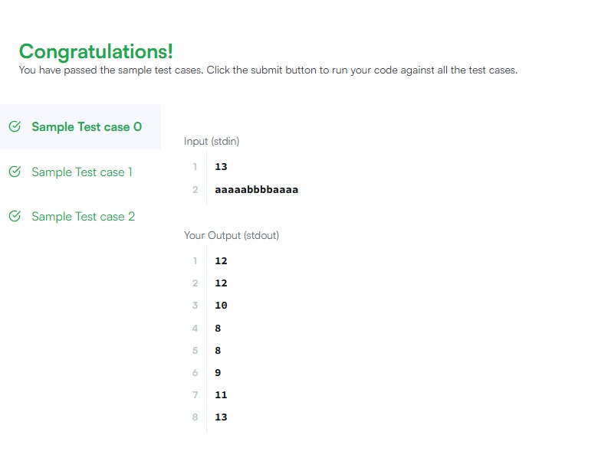

RESULT: Thus, the program has been executed successfully and output has been verified.

